Week 1 -- Lab 1
UVM Agent For APB Bus Master
Objective
To understand the basic structure and working of a UVM testbench.
Theory
UVM (Universal Verification Methodology) is a SystemVerilog-based methodology used for verifying digital hardware designs.
A basic UVM testbench contains different components, where each component performs a specific task. In this lab, the main components are:
Sequence
↓
Sequencer
↓
Driver
↓
DUT
↓
Monitor
This separation makes the verification environment organized and reusable.

Task 1: Build a simple UVM testbench for a counter DUT
DESIGN
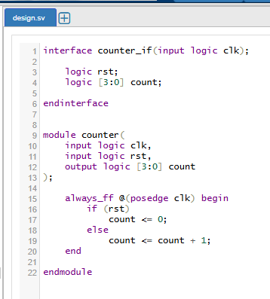

TestBench
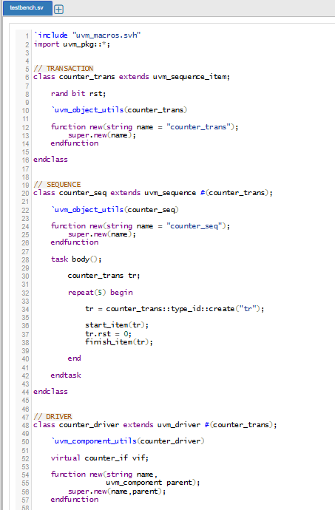
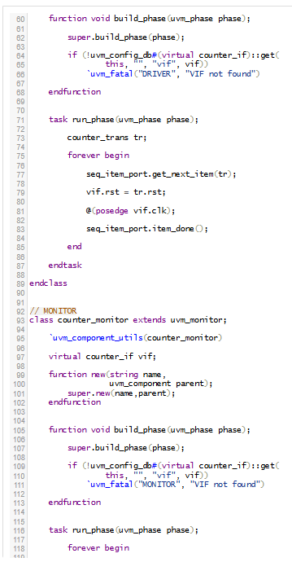
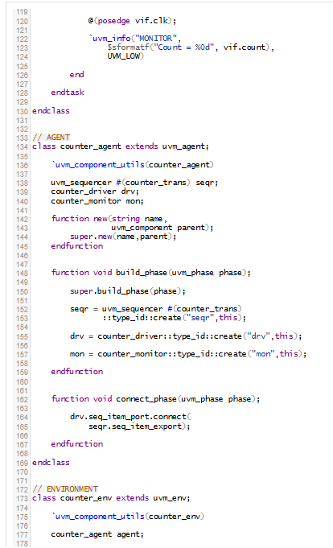
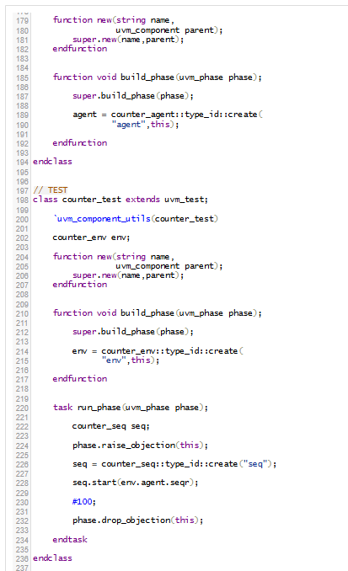
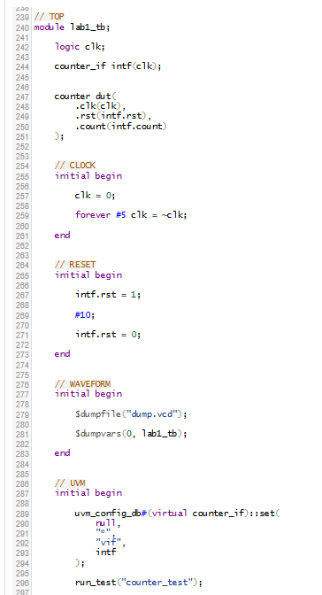
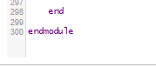

Result
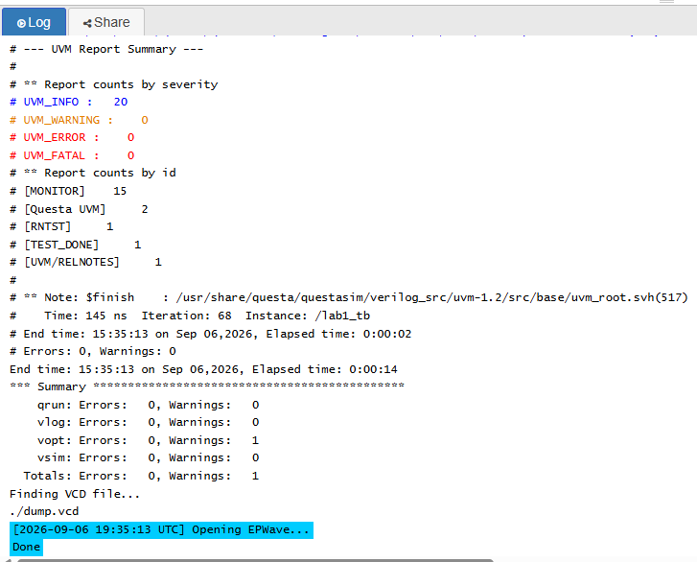
Waveform
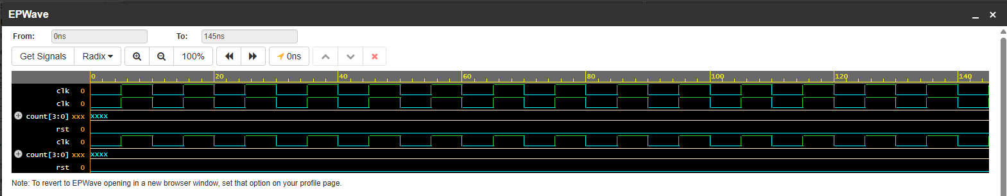

Task 2: Create a UVM agent for an APB BUS Master. Drive Transaction from sequencer to driver then DUT. Collect Transaction in monitor.
DESIGN
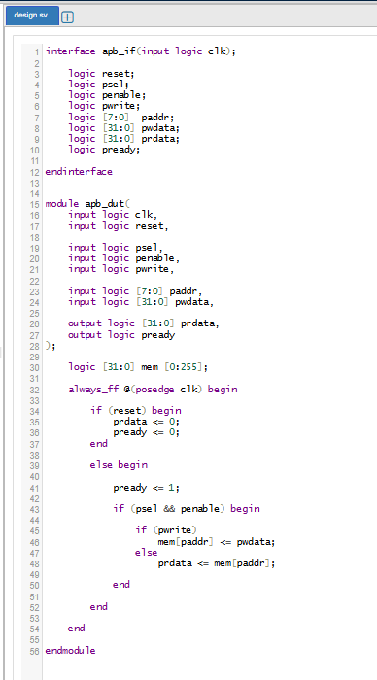
Testbench
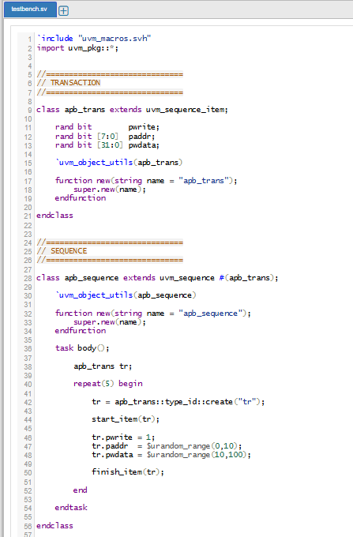
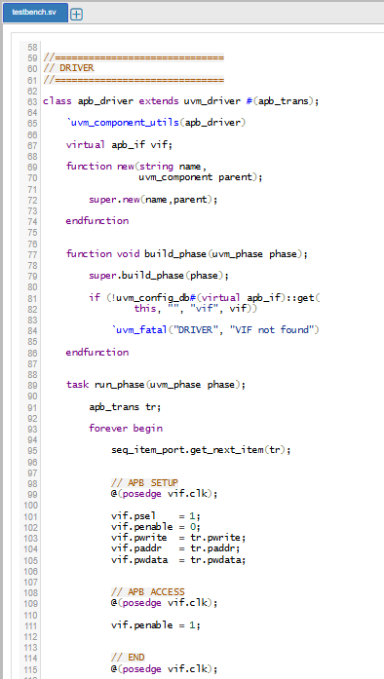
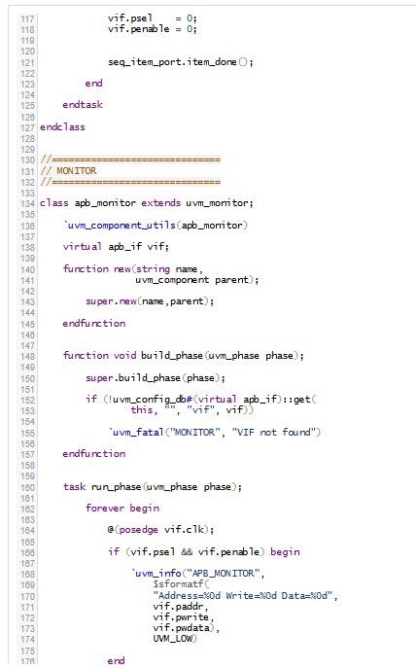
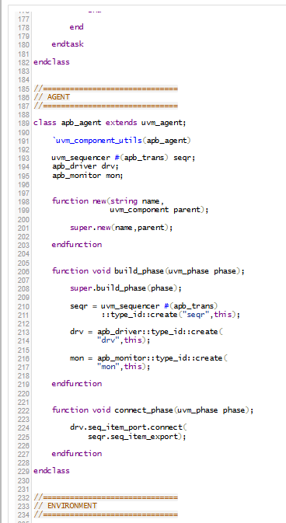
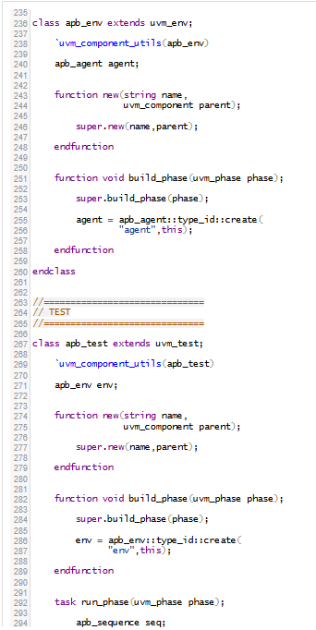
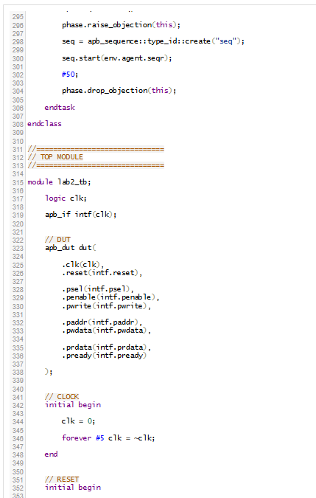
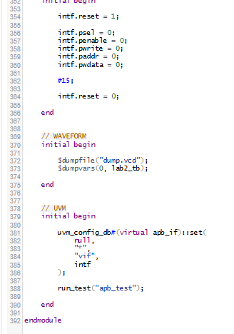

Result
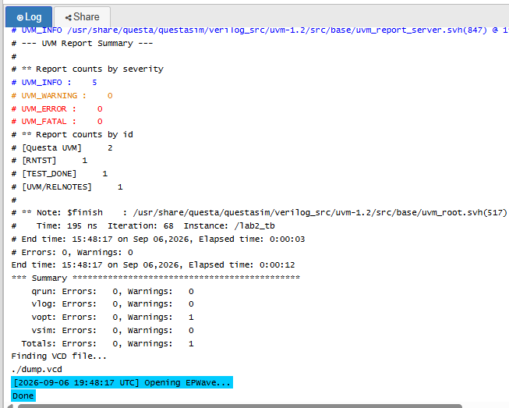
Waveform
